Southborough & District Wheelers

www.southborough-wheelers.co.uk

10-mile Open Time Trial (Q10/33) 17th May 2014

For and on behalf of Cycling Time Trials under their Rules & Regulations

### Award List

|  |  |  |  |  |  |  |  |  |  |  |  |  |  |
| --- | --- | --- | --- | --- | --- | --- | --- | --- | --- | --- | --- | --- | --- |
| **Scratch** |  |  | **Improvement**  **on LTS best** | |  | **Vets** |  |  | **Fastest Team** |  | **Lady** |  | **Under 18** |
| First | £35 |  | First | £25 |  | First | £25 |  | £60 |  | First £20 |  | First £20 |
| Second | £25 |  | Second | £20 |  | Second | £20 |  | (3 x £20) |  | Second £15 |  | Second £15 |
| Third | £20 |  | Third | £15 |  | Third | £15 |  |  |  |  |  |  |

### Course Q10/33

Start on the B2080 at the junction of hedge and fence on the north side of the Green and East of the lane to Finchden Manor, Leigh Green at GR 901330. Proceed through Reading Street to Appledore Heath. Turn left (CARE) (M) to Woodchurch where the road becomes the B2067. Bear left through Brook Street to finish at the verge immediately after the lane to Finchden Manor (GR909380)

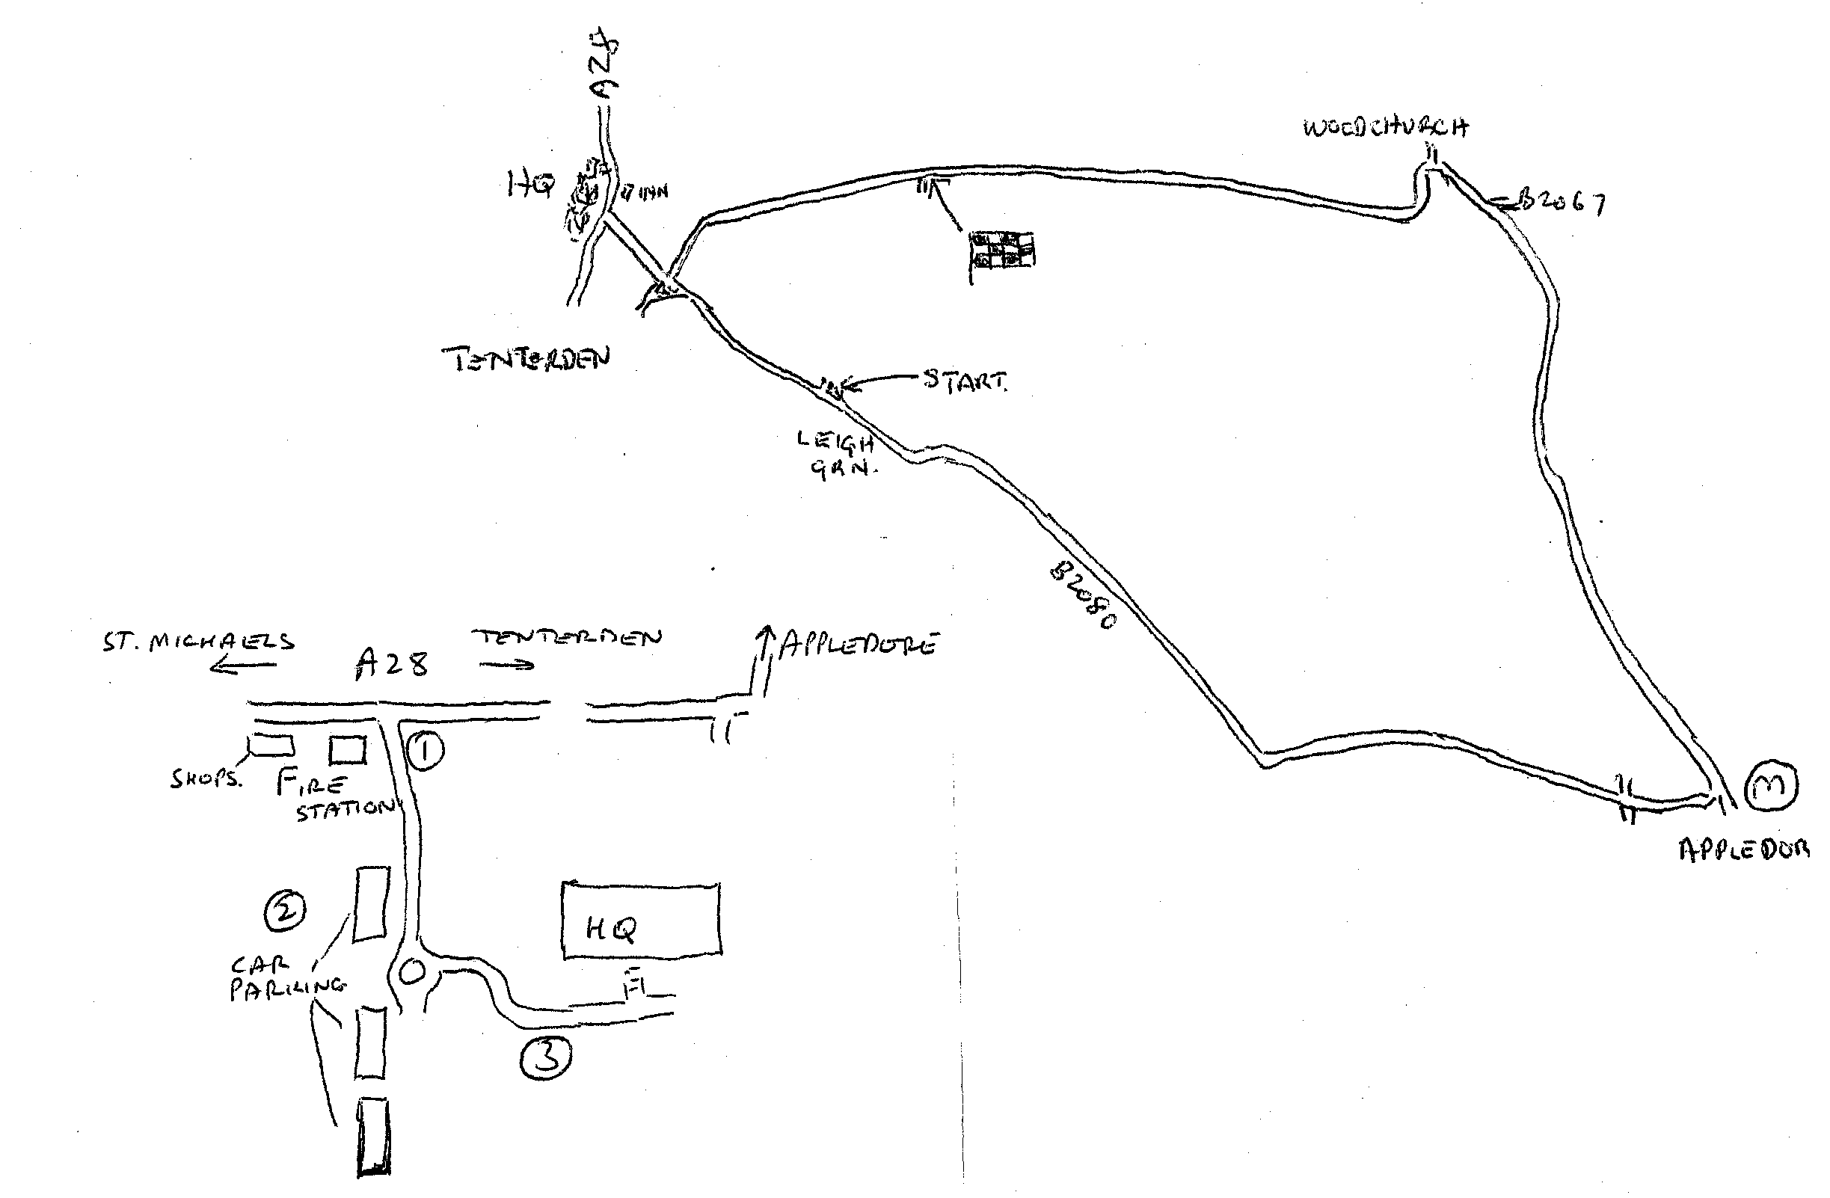

The Headquarters is **Homewood School and Sixth Form Centre, Ashford Rd, Tenterden.**

1 – Please use entrance off A28 by Fire Station

(**NOT** **THE MAIN ENTRANCE**)

2 - All parking adjacent to roundabout

3 - Footpath up slope to HQ

Competitors must sign on using the sheet provided at the number collection point in the HQ.

No shoe plates in the hall please.

Please exchange your number for a cup of tea / coffee after your race.

### Timekeepers

David Watson and Les Hayman

### Event Secretary

Doug Finch, 9 Hamlin Road, Riverhead, Kent, TN13 2DL

Tel 01732 452788

Email [dougnlorna@btinternet.com](mailto:dougnlorna@btinternet.com)

### Additional Information

* Riders must not warm up / turn in sight of the start finish areas
* Riders must beware traffic from right on all roundabouts
* All riders under the age of 18 years must wear a properly fixed helmet that complies with recognised standards
* CTT and the event promoter strongly advise all other riders to wear protective headgear
* It is recommended that a working rearlight, either flashing or constant, is fitted to the machine in a position visible to following road users and is active whilst the machine is in use
* Riders who currently use an inhaler for medical reasons must register this fact with British Cycling to satisfy UCI, CTT and BC Anti-Doping Regulations.
* It is an offence for a competitor in any event to use or to have administered to him any proscribed substance that might affect his competitive performance. A rider receiving medical treatment, which could include a proscribed substance, must not compete in time trials.